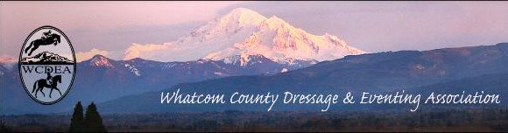
  - JUNE 15, 2017

CONTACTS

President:
Kat Southam-Fay
katsoutham@gmail.com

Vice President:
Garyn Heidemann
garynheidemann@gmail.com

Treasurer:
Holly Nachbar
hnachbar@comcast.net

Secretary:
Kelly Dress
kjdress@gmail.com

Website Coordinator:
Michelle Becker
goddessgirl19@hotmail.com

Email Distributor:
Linda Cain
cainshome4@gmail.com

Like us on FaceBook:
https://www.facebook.com/wcdea

Website Address:
wcdea.net

NEXT HAPPENING ~
JULY 13th 6-8pm at Cain Lake Stables

Equestrian Sports Psychology with Shannon Thompson
See last page of news FOR DETAILS

“Barn-Voyage” Party to honor
Jodi Kemp
It is hard to believe, but it is true. Our dear friend, Jodi Kemp and her husband, Brett, are really moving to Montana. I know, they did not consult with the rest of us first and now it is a done deal! They will be making their move the end of July. A "barn-voyage" will be held in Jodi's honor on Saturday, July 15, between the hours of 10:30 am and 2:30 pm at the home of Mechelle Sieg (8969 Jackman Road, Lynden). Please plan to schedule time that day to stop by and wish Jodi well on her new adventure.
RSVP : memesieg@aol.com

Ed. Note: Jodi will be missed by all of us as she has been a friend and WCDEA member for a VERY long time. A constant source of encouragement, Jodi is known for her ever present smile and positive attitude. As the absolute definition of volunteer (see below) she has filled positions as Show Chair, and events volunteer in many capacities. The club will be looking to others for the roles Jodi so willingly filled over the years. A huge shout of thanks to Mechelle (another true volunteer) for offering not only her time but also her home for this fabulous gathering!

vol·un·teer
This could be a photo of any number of our members.
Is it you?

välənˈtir/
noun
noun: volunteer; plural noun: volunteers
1. A peerson who freely offers to take part in an enterprise or undertake a task.
  - a person who works for an organization without being paid.
  - a plant that has not been deliberately planted.
verb
verb: volunteer; 3rd person present: volunteers; past tense: volunteered; past participle: volunteered; gerund or pre[Type a quote from the document or the summary of an interesting point. You can position the text box anywhere in the document. Use the Text Box Tools tab to change the formatting of the pull quote text box.]
sent participle: volunteering
- Freely offer to do something. Perform services willingly without pay.

Rated Show gets RAVE Review
by Rikki Smeltzer

The recognized dressage show put on by the BC Sport Horse Association at the Lynden Fairgrounds on May 25th was awesome for so many reasons.
First, it was right in our back yard! I left my house, horse in tow, at 6:30am, rode two tests and was back at home completely unloaded by noon. This is huge - unheard of even!
Secondly, it was an affordable recognized show. I’m talking racking up those scores for your medals! Did I mention it was right in our back yard?! No leaving the night before, stabling and waiting around to ride all day. This was an in and out thing.
Most of all, though, what I really appreciated about the show was the incredible show of support from the WCDEA volunteers. This was my first rated show and honestly I wasn’t sure what to expect. It was so nice to be in warm up with fellow WCDEA riders and to know all of the volunteers: the runner, the gate keeper, the scorer and the scribe were all familiar faces. Everyone milling around was full of smiles and genuine encouragement. Overall this was an amazing experience. It was a low key, fun and supportive atmosphere and I even earned a qualifying score towards my bronze medal!
Thank you to everyone behind the scenes who helped make the show happen in the first place and to all the volunteers who came out on a beautiful, sunny day and filled all the volunteer spots. I hope this becomes a regular show because it was so convenient and fun!
Ed. Note from Deb: Thank You for the submittal Rikki and Congrats on your qualifying score! I had SO hoped to compete at this show, but was called away to work in Utah for the three weeks prior. So, I scrapped that plan – but, because I believe this show is a great idea and hope to see it happen again, I offered to volunteer. I was pleased to see so many of our steadfast crew helping to man the various stations of the dressage show. Show Chair, Peter Morrison offered many compliments to the WCDEA for all the “capable help” and various sponsorship that came by way of our club – WAY TO GO EVERYONE!
Photo credit and notes by Dawn Morgan (that I stole from FaceBook without her knowing)
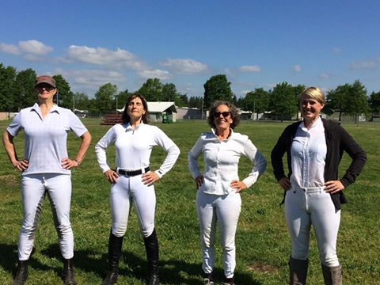
A big shout out to these amazing wonder women of the WCDEA! Kerstin Decook, Mechelle Sieg, Patty Yust, and Rikki Smeltzer were the first to ride down centerline in Whatcom County's first rated dressage show! They had great rides, lots of fun, and carried the torch for our club! A special thank you to The Greater Vancouver Morgan Horse Association for their hard work to put together and sponsor this event for us to enjoy. We are grateful and looking forward to 2018!

In other BIG news…Longtime WCDEA member, Kim Roe received her “r” judge’s license!!! Getting all set to judge some rated shows - Way to GO KIM!!! A lot of hard work and dedication to the sport of dressage went into meeting this goal and we are ALL proud of your accomplishment.
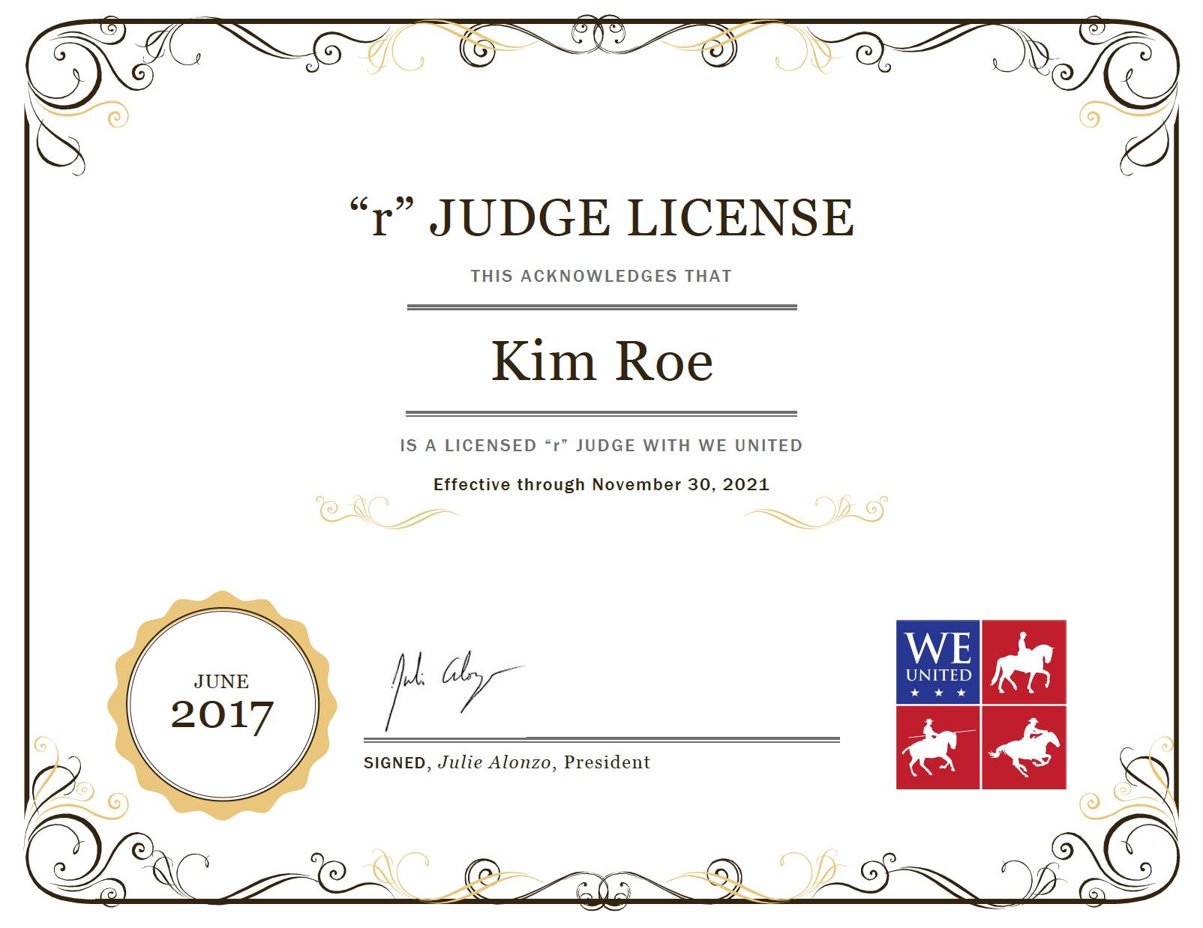

(As published in the MAY SECOND EDITION) NEW BUSINESS with pending questions/answers because our stream of information seems to have a few logjams:
- July fun day at Sunset Park. We need someone to organize the event. Members can bring their horse to ride in the park. Historically we have had rides, games, food, and fun. The July business meeting will be held at this event.
Question – What is the date and time of this event?
Question - Will we still be having a potluck and business meeting if no one steps forward to organize the “games we play”?
The board responded: The July FUN DAY has been cancelled
(Ed. Note: No word on when or where the July business meeting will take place since it was scheduled to happen in conjunction with the fun day)
- Harvest Classic schooling show – Garyn Heidemann has offered to organize the event with Emily Dieleman. Tentative date is September 9 or 10. Tentative location is Broken Auger Farm. We need volunteers for all roles.
Question – Has anyone contacted Broken Auger to confirm the date/availability?
Question – Do we have a Judge lined up?
The board responded: I don't believe we have yet worked on the judge for the broken auger show. It is still several months out and we have many new L graduates in our area along with the old L graduates. I believe that will be an easy thing to fill. We cannot currently announce the judge but I do believe the location has been secured.
We are looking for someone to take on the role of Chairman of Membership. This job within the WCDEA will be to promote club activities and draw in members. This person will need to communicate with other equine clubs to offer involvement with our events. We would like to reach out to the equestrian youth to gain interest in WCDEA.
Alexandra Brooks will be our new Chairman of Membership.
(Ed. Note – not enough time with this announcement sent to me yesterday, in order to offer the membership a decent introduction in the newsletter by way of a “Member Spotlight”)
Business meetings are scheduled for July, September, and November.
Great Expectations and another Goodbye
It is with mixed emotions that I share with you the following news. As you know, I have acted as the editor of the newsletter for several years – even from far away lands as I have traveled for work and pleasure. I have enjoyed doing so and have asked for submission of newsworthy offerings from our members. This has posed its own challenges. The internet and inconsistent use of website and facebook of club notifications does not help. Still, together we managed to put out a decent amount of news on a monthly (sometimes with second/special editions) via our emailed copy as promised in our membership benefits. I have to thank all of you who have submitted various articles – the many book reviews, equine product comparisons and reviews, various showing experiences beyond the WCDEA. I hope you have enjoyed it as well.
The letter attached below was received on June 8th. No mention of any discussion at the last club business meeting that I am aware of unless it was struck from the minutes (?) and still no mention of who the “other club member” with desires to edit is.
I would like to say that I have never denied anyone the opportunity to submit newsletter offerings and have encouraged ALL members to send/submit any and all information to me for inclusion. It’s my belief that a club like ours will only survive if all are included and that if any kind of exclusive behavior exists, it will be the death of a fantastic pool of volunteer efforts.
Unfortunately, in our fast paced, over scheduled world, it seems posting on Facebook is the chosen path of “getting the word out” to the masses. I have had to chase down a lot of club related information after the fact for inclusion in the newsletter. My apologies if the newsletter seemed less than “news” because of the failings of others to follow suit.
My dedication to the club and promotion of the sport(s) it supports is unyielding. In that, I offer nothing but the very best wishes to whomever is replacing me in the efforts of newsletter editor.
I look forward to seeing you all very soon.
Legs on – Tally-ho!
-Deborah Cole-
Sent via email:
Dearest Deb,
On behalf of the board I first want to say how much we (and of course the entire club) appreciate your amazing dedication as newsletter editor. Its always been very clear that you share our common goal of improving the club and providing an important service to our equestrian community.
It was with these goals in mind that we first raised the idea of providing you with a "content editor" who could help source more content for the newsletter. In the end it seems that idea wasn't favored and we returned to "business as usual". That said, we still very much agree with your initial suggestion that the newsletter needs to be more robust. We've recently had another club member express a lot of interest in taking on the task of editing and content sourcing. We'd love to give her the opportunity as she has the time and inspiration to reinvigorate the newsletter and take it to the next level. We hope that you'll also be excited by this opportunity as it will hopefully be the boost we all feel the newsletter has needed.
Let me again reinforce the fact that we are so very grateful for everything you do and we hope you ll agree that this is an exciting opportunity for the club and the newsletter!

Sincerely,

The WCDEA board

Kat, Holly, Garyn and Kelly

As sourced from a FaceBook invitation:
(Mark your calendar and make it happen) JULY 13th 6-8pm

Equestrian Sports Psychology with Shannon Thompson

The WCDEA is so excited to welcome Shannon Thompson for another sports psychology clinic! Shannon specializes in mental training for riders of all levels and diciplines, whether you have been riding competitively for years, are new to the show ring or don't plan on showing at all you are guaranteed to take away new tools and a fresh perspective on the mental aspect of our sport. The work shop is interactive and all participants are given a work book to take home. Topics include mental resilience and the benefit of struggle, understanding optimal performance mindset and overcoming fear. Everyone is encouraged to come out for this, it is sure to be an inspiring evening!
Cost: $25 members, $30 non-members
IMPORTANT: All participants must pre-register by clicking on the link below and adding your name to this list. This way we know how many workbooks to prepare. Thank you for your cooperation!
https://docs.google.com/spreadsheets/d/1P7WzvLHPJ-VPLcKczx12i81V2UvaFnjb6SItHUsKqM0/edit?usp=sharing

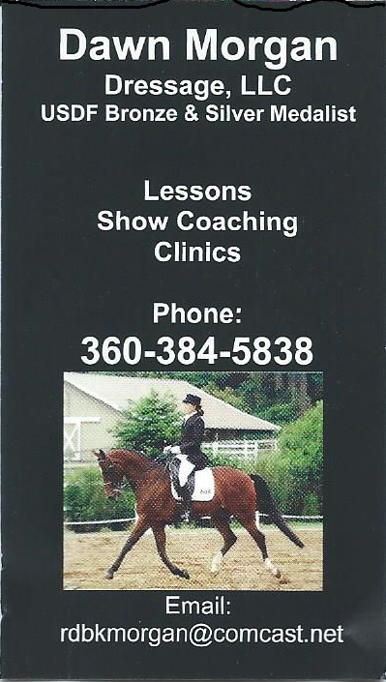
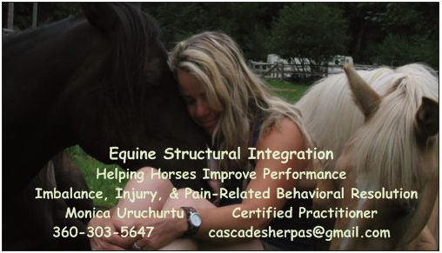

FOR SALE:

** Parma ARENA Groomer in good condition - 3 point hitch type for $1,000

(half price of new one). Contact Barbara Daugert at bdaugert@gmail.com or phone 360-483-8031.

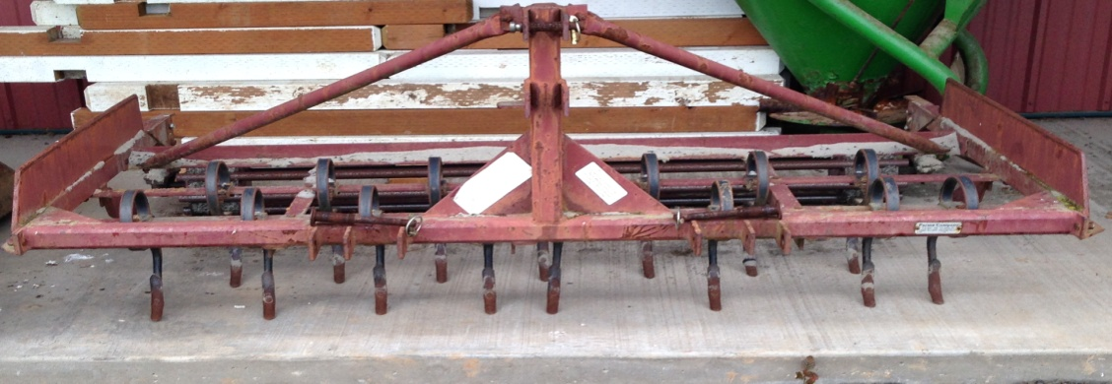

WCDEA News is published and distributed to the WCDEA membership. We value your ideas and opinions – PLEASE let the editor know of any items that could be included as news for future publications http://wcdea.net

