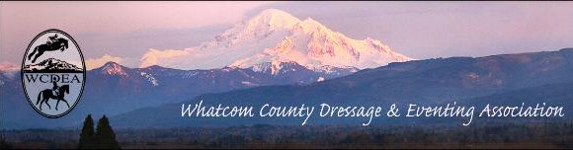
  - JANUARY 5, 2017

CONTACTS

President:
Emily Dieleman
emilyjdieleman@gmail.com

Vice President:
Kat Southam-Fay
katsoutham@gmail.com

Treasurer:
Holly Nachbar
hnachbar@comcast.net

Secretary:
Kelly Dress
kjdress@gmail.com

Newsletter:
Deborah Cole
dchoneydofarm@gmail.com

Website Coordinator:
Michelle Becker
goddessgirl19@hotmail.com

Email Distributor:
Linda Cain
cainshome4@gmail.com

Like us on FaceBook:
https://www.facebook.com/wcdea

Website Address:
wcdea.net

NEXT HAPPENING ~
CPR & First Aid with an Equestrian Twist
Saturday, January 14
(see inside for details)
NEXT MEETING ~
ANNUAL PLANNING SESSION
January 19th
El Gitano ~ Sunset Square Bellingham
6:30 to eat ~ Meeting starts at 7
On December 10, WCDEA members met for a wonderful Christmas party at the home of Erin Recke and Shanna Leland. Although the weather was threatening more snow and ice, we had a good turnout. As usual, we had an abundance of amazing food and drink. Our annual gift exchange was lively, we got to meet with friends new and old, and celebrate another year with the club. Many thanks to Erin and Shanna, new members, who stepped up to host our annual get-together. They have a beautiful home and were lovely hosts.
Thank you all for your membership and for making all of the activities and programs we put on possible. Without our members, none of this is possible. I was very honored and humbled to receive the 2016 Volunteer of the Year award. I want to thank each and every person who helped out this year, whether it was scribing for our dressage judge, providing food for an event, or setting up before show days. You make this possible, and I hope we can have another successful and fun year in 2017.
Emily Dieleman, WCDEA President
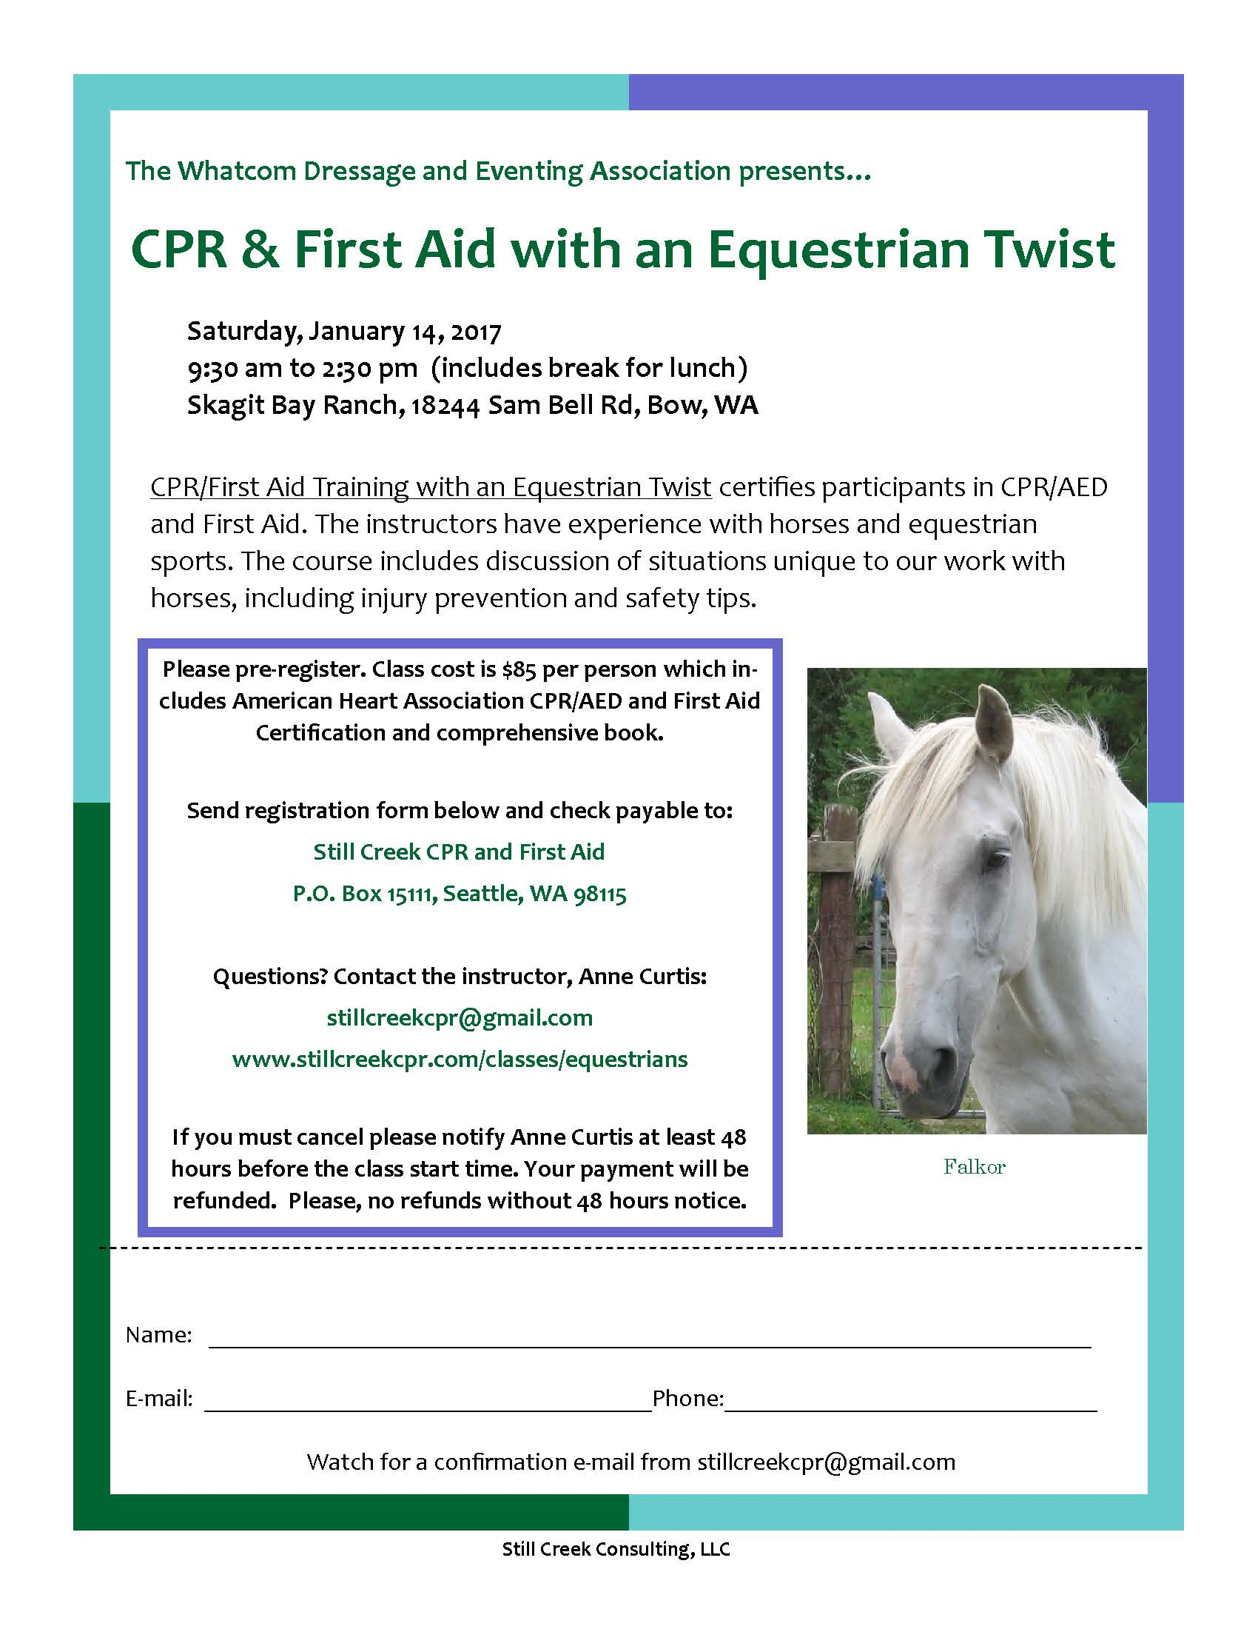
2016 WCDEA Award Winners were announced at the Holiday Party ~ Special Thanks to our Awards Coordinator Deb Palmblad for putting all this together!

Garyn Heidemann and Diego earned their GOLD medal at 4th level – the highest medal the club has awarded to date! All scores were earned at “A” level shows, huge congratulations!

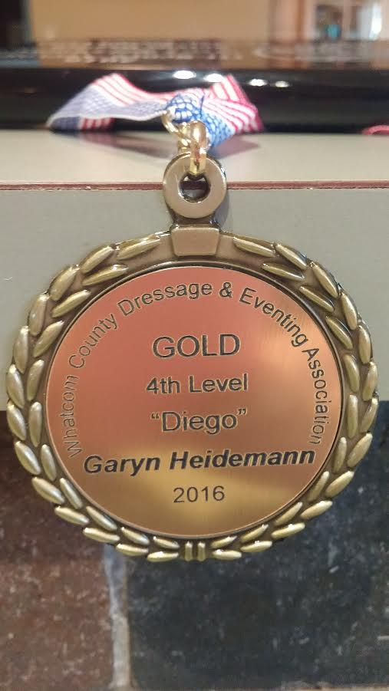

Novella Randall and Leo’s Red Licorice earned their SILVER medal at Third level – their first season together, all 4 scores earned at “A” shows…. Congrats!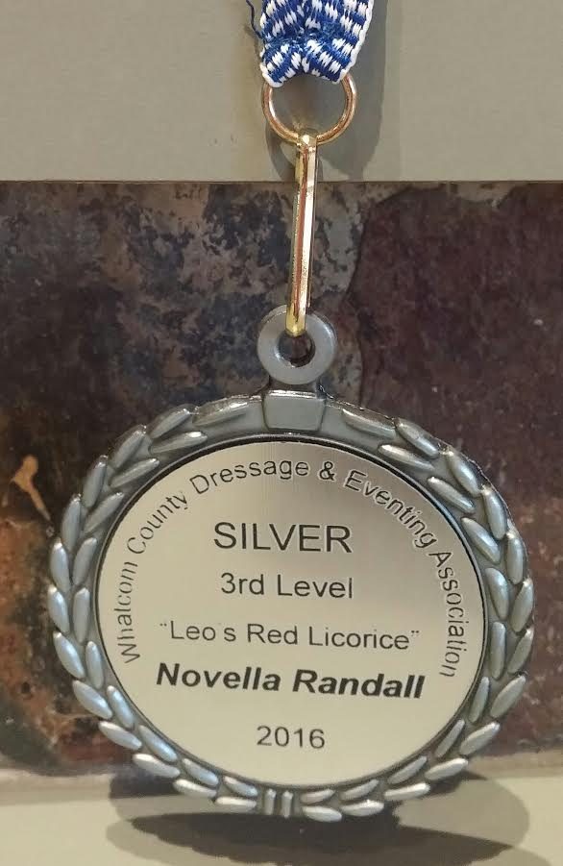

Kelly Dress and her mare Caliente earned their SILVER medal at Training Level – all scores earned at “A” level shows, Congrats!
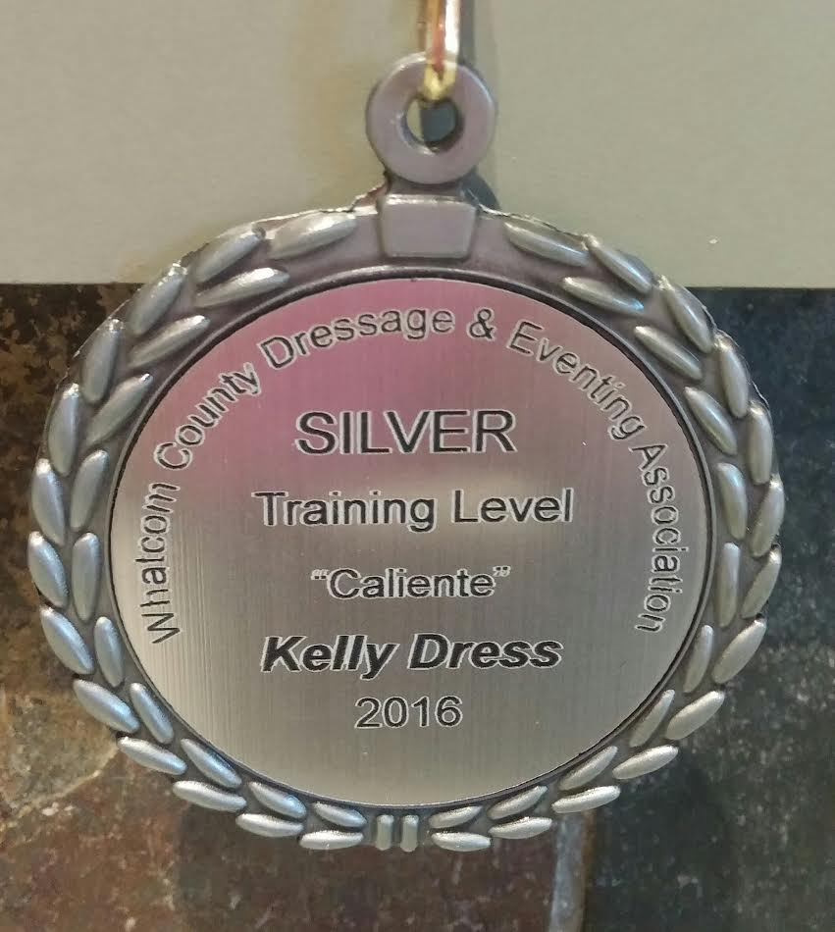

YOU CAN Earn Your Own Bronze, Silver, or Gold Medal in 2017:
BRONZE 4 scores from 3 different judges (at least 55%)
SILVER 4 scores from 3 different judges (at least 60%)
GOLD 4 scores from 3 different judges (at least 65%)

2016 High Score Award went to Novella Randall riding Leo’s Red Licorice for a combined average score of 68.65 % at Second Level – the highest level we have awarded this achievement to – congratulations Novella!
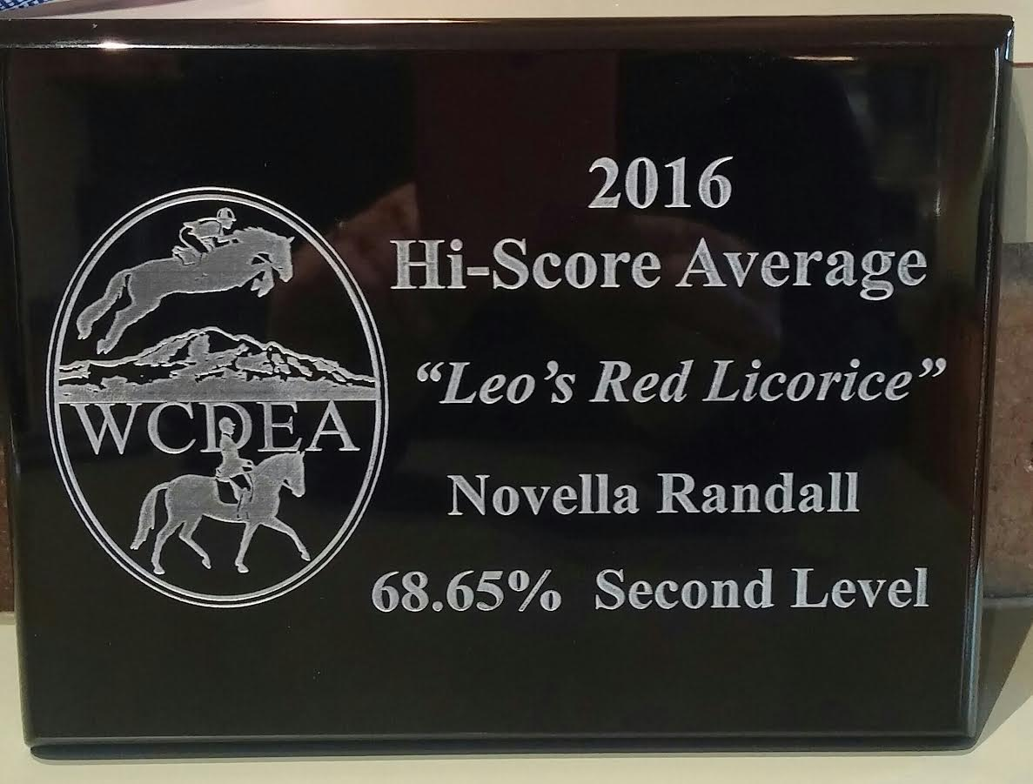

2016 Miriam Younce Memorial Award goes to Kelly O’Toole and her gelding Gabriel – for earning the highest score at 1st Level or above at the WCDEA Fall Show. Congratulations!
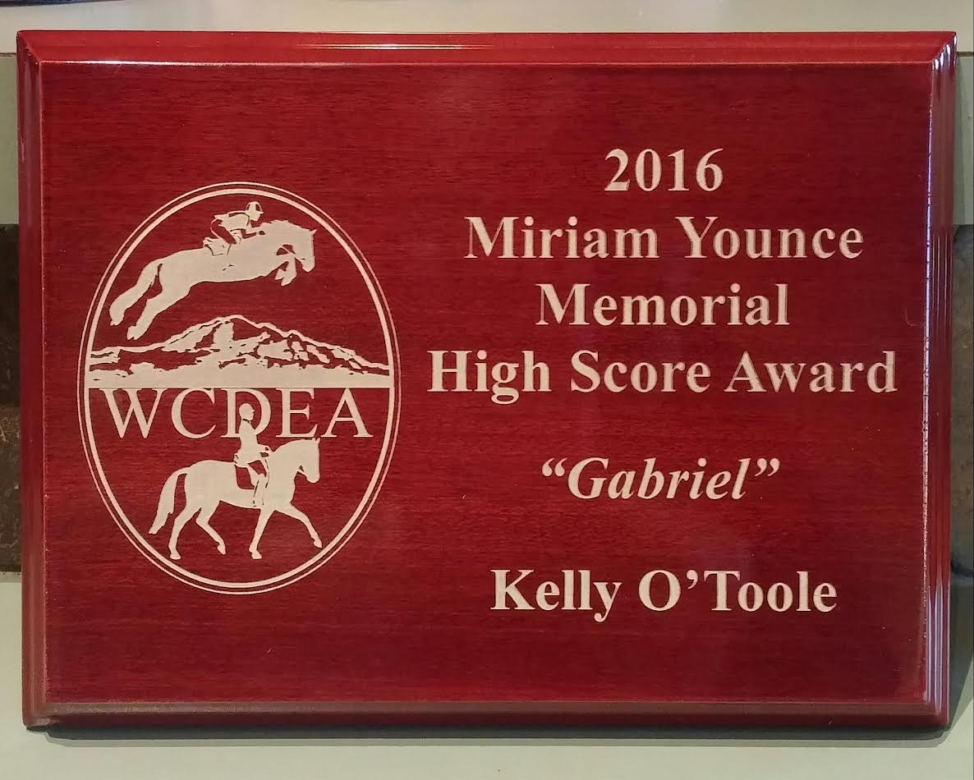
Our very industrious, chosen leader was also voted as this year’s Volunteer of the Year – Thank you for all the hard work Emily!
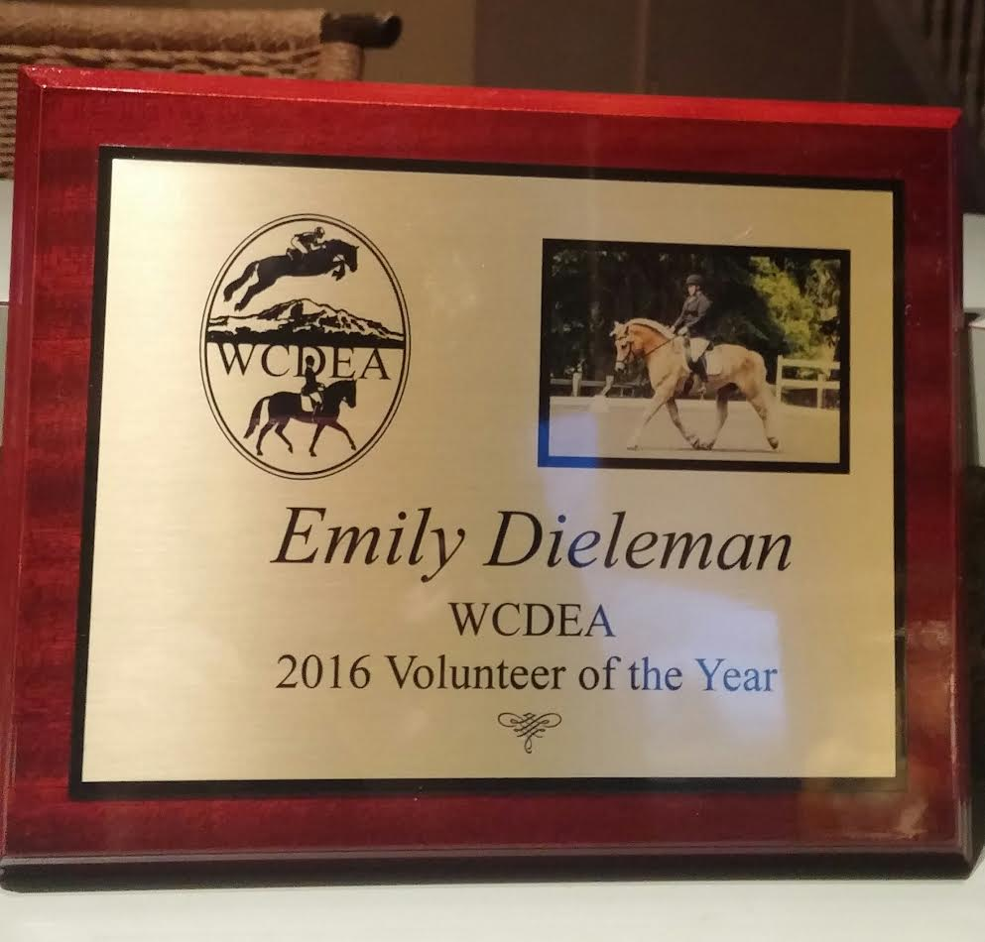
Each Medal Winner received a $10.00 gift card from Laurel Farm Supply to spend however they wish. Please thank Laurel Farm next time you are in for their continued yearly support of our riders. Congratulations to all!
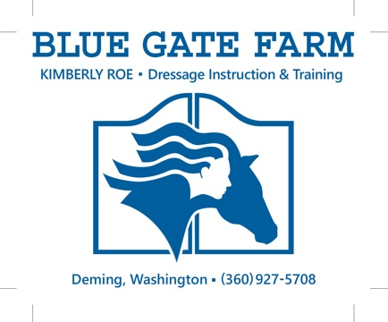

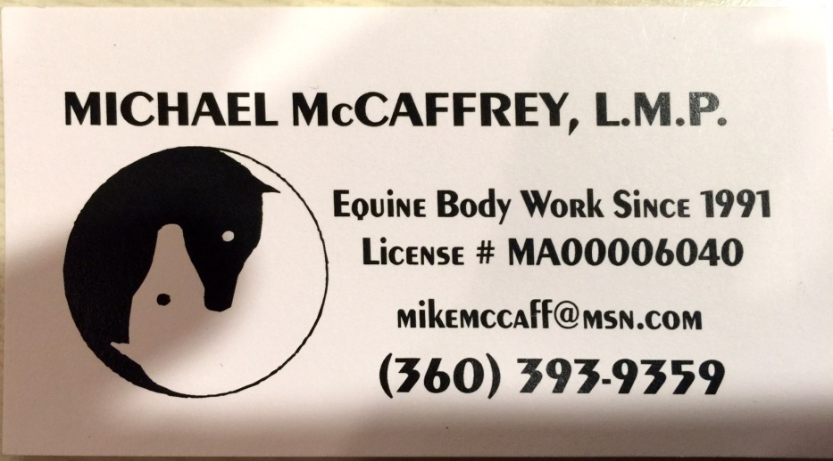

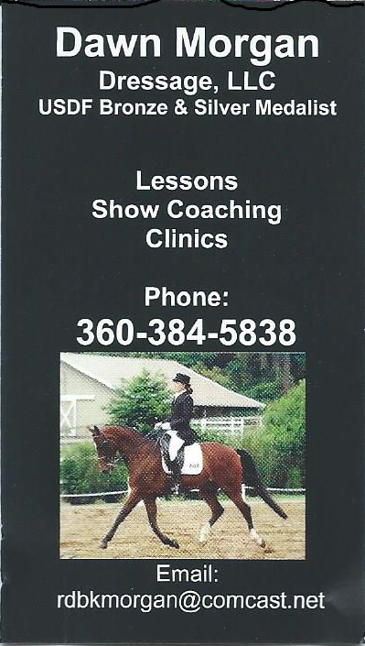

FOR SALE:

** Parma ARENA Groomer in good condition - 3 point hitch type for $1,000

(half price of new one). Contact Barbara Daugert at bdaugert@gmail.com or phone 360-483-8031.

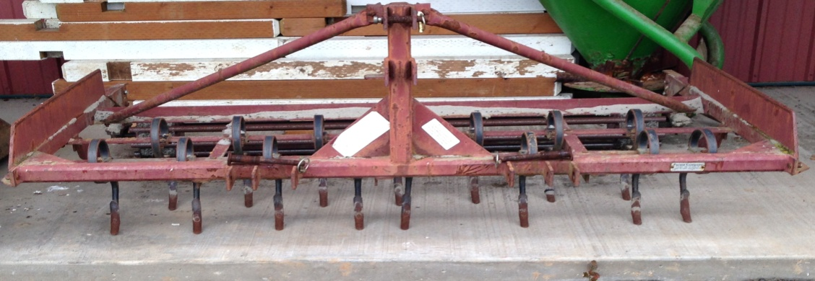

WCDEA News is published and distributed to the WCDEA membership. We value your ideas and opinions – PLEASE let the editor know of any items that could be included as news for future publications. (please know that stories will be checked out for accuracy prior to print to the best of the Editor’s ability) Send your News Submissions to: Deborah Cole via email: dchoneydofarm@gmail.com. WCDEA members meet monthly (typically) at various locations announced in the newsletter and website at http://wcdea.net

