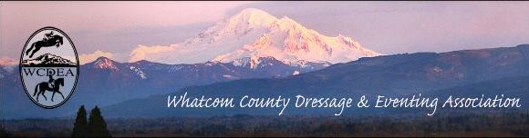
  - May 14, 2019

NEXT MEETING
CONTACTS

President:
Kate Simmons
andykatys@gmail.com

Vice President:
Robin Probst
rphrse@msn.com

Treasurer:
Carol Landt
landthuber@gmail.com

Secretary and
Website Coordinator:
Michelle Becker
mbecker704@gmail.com

Newsletter Editor:
Deborah Cole
dchoneydofarm@gmail.com

Mass Email Distributor:
Linda Cain
cainshome4@gmail.com

Like us on FaceBook:
https://www.facebook.com/wcdea

Website Address:
wcdea.org

May 18th ~ Deming Library

5044 Mt Baker Hwy

6:30-8:00

Brief meeting to recap the Ride A Test and then

Kim Roe presentation

on Working Equitation
​
April Meeting Minutes
Members attending #4
Meeting Called to order 7:06
Financial Statements: Peoples Bank –
Checking $ 1,389.83
Peoples savings:
Calendar $300.00
Leg Up Fund $487.24
Savings (regular) $2,632.17
Total Peoples savings (regular) $3,419.41
Total Checking/Savings $4,809.24

Old Business:
It was mentioned that the educational events seem to be well attended. Deb reported that Dr. Revena (sp?) is giving a presentation on equine wellness in Snohomish, and will look into the possibility of having them present, possibly in Sept. or Oct.
Speaking of events, Carol and Kim are co-chairing a working equitation show at Sunset in August. Lynn Salas will be doing the awards. Saturday may be a clinic, with only folks who have come to Kim’s talk or attended her clinics being able to participate. The show would be on Sunday, and everyone could come to that.
The Event Derby is happening on August 3rd, and Kate is working with Robbie to find a date for a pre-clinic, “How to ride a dressage test” or “Jumping basics for beginners.”
Hosting a fall show, possibly called the “Alt-Championships” was briefly discussed. Deb is interested, and Michelle and Kate could possibly co-chair. There was talk of offering dressage equitation classes.
We discussed again, the possibility of getting something into the NW HorseSource about the different organizations/clubs in the Northwest.

New Business:
Kate brought up her idea of a “points system” to encourage members to participate. People could earn points for showing up to meetings, for getting their entries in early, for all sorts of things. This can be a good way for people to feel involved, even if they can’t necessarily ride. Dressage Bucks will still be used too! Especially if we have non-members do things like volunteer at shows. The Bucks can be used for entries and for joining the club… so a bit of a lure to get them to join ☺.
It was agreed that the points system sounded good to try as a pilot, so Kate will be starting this year.
The next meeting will have a 6:30 start time- because we need to be out of the Deming Library by 7:55.
Also, just for everyone’s general interest- there will be a Masterclass with Laura Graves in Langley on June 1-2nd.
These minutes will not be read at our next upcoming meeting. If there are any corrections, please email board members.
Meeting was adjourned at 7:40pm.
Respectfully submitted,
Michelle Becker, WCDEA Secretary

BIG NEWS…No
HUGE…
SUPER IMPORTANT…PLEASE NOTE
The WCDEA website domain has changed to “.org”
So, the new, slightly changed address is now
www.wcdea.org
Michelle’s Mini-Trip to Wellington
In March I went to Florida to visit my grandma in Gainesville, but I decided to also treat myself to a mini solo vacation to Wellington. (I mean, I was going to Florida anyways, so why not?!) I only had a short time to fit in as much horsey-ness as possible because I was in Florida to see my grandma who I hadn’t seen in ten years, after all. I Had to try to be a good granddaughter…right?
After a long day of traveling, I arrived at the lovely AirBnB I reserved for two nights. The Seabreeze Cabanna is a 10-15 minute drive to the show grounds. (Affordable, comfortable and convenient = Perfect!)
There was, of course, a lot of equine activities going on the weekend I was there. A dressage show which was not a big show, but still a show at Wellington. There was also the $50,000 Hermes Under 25 Grand Prix Series Final happening on the Derby Field. And last, but certainly the more comical part of my adventure, was the Gladiator Polo…
I arrived at the show grounds nice and early, and just wandered around taking it all in. (Debbie’s reserved parking spot!!):
Beautiful, groomed arenas and sunny skies, and vendors, lots of vendors. I definitely had to try on some beautiful, custom boots that I could not afford, at least not right now, and definitely perused some of the other vendors. 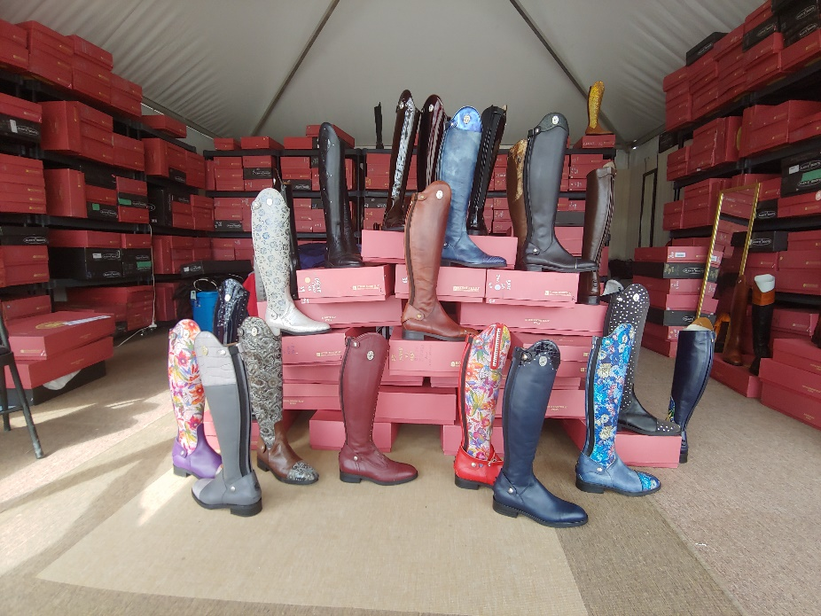

Then some tests began, so I watched for a bit. The horses were lovely, the tack and outfits were very nice, and the riders were definitely decent. They were normal (albeit wealthy and with more time than most of us) folks. No Olympic riders here, but definitely people who can take regular lessons.
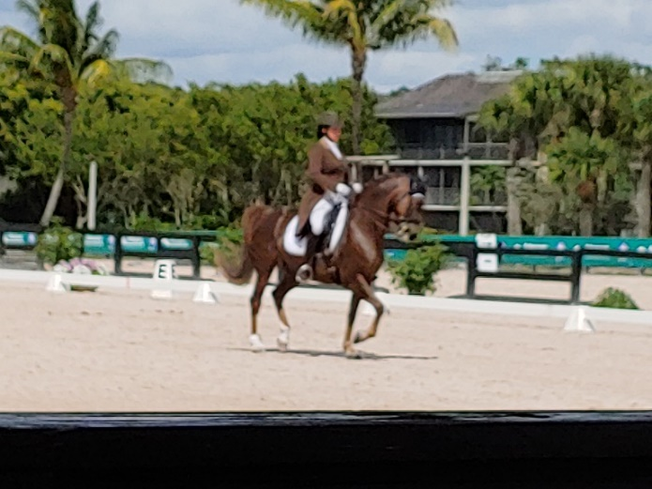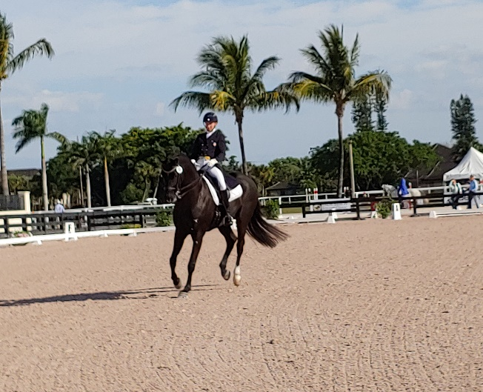
During a slow time in the dressage rings, I walked over to the derby field and watched horses jumping jumps that looked as tall, or taller than I am. It was pretty dang impressive. One stallion decided to have a melt-down about half-way through the course, and we spectators all backed away nervously (since we were just standing on a hill in the jumping grounds). His rider got him under control and they left the field. We all sighed a breath of relief. One thing that really impressed me, besides the height of the jumps, was the speed of each ride! These riders were in and out of this big field within about a minute and a half, jumping 13 obstacles. Definitely some impressive riding!
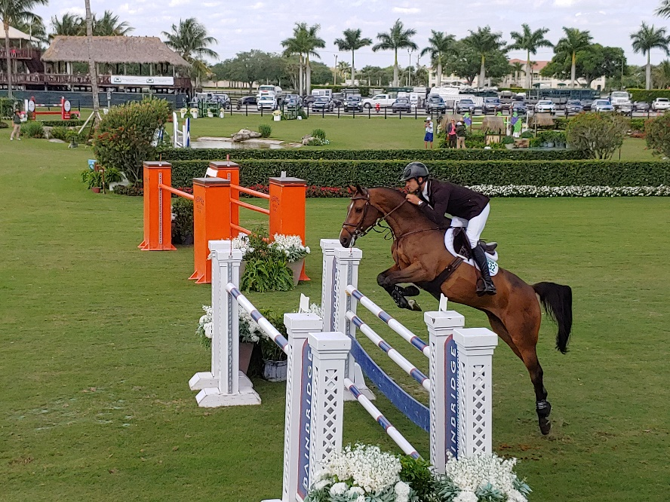

During the lunch break I drove to a consignment store, On Course Consignment. I found a few things I needed, like another girth, some small clippers and a really cute hunt coat that I will definitely wear to work as a blazer. That store was big, and had so much stuff! There was a pair of boots that I absolutely fell in love with, but I would have had to cut off some toes for them to fit. Sigh…
I headed back and watched more dressage tests including some musical freestyles (always my favorite!), and wandered through the vendors, and maybe found a few things in the sale bins that had to come home with me, including a Cavallo cap, a Boy-O-Boy Bridleworks belt, and a cute shirt. I was pretty proud of myself for keeping the spending at a reasonable level.
I headed back to the Cabana for a little chill-out time before getting cute for watching Gladiator Polo and eating ring-side.
I learned a few things from this whole polo experience. One is that you should always pack at least one pair of cute shoes (more on that in a minute); Second - never completely trust your GPS. It’ll get you close, but maybe not completely there.
So, I got myself ready with what I had packed (since this polo thing was a last minute adventure, I really hadn’t packed anything that cute/fancy). But I thought I was looking fairly cute:
(Note the Old Navy flip-flops. Definitely the outfit of a style icon…).
Anyways, I pulled up the address on my trusty phone and headed out the door. I drove to the address and followed another car to where I saw cars parked in a field. At this point, I saw no horses on the polo field, but thought maybe they were starting the match a bit late, and giving the spectators get a chance to eat. I walked into the International Polo Club and felt out of place immediately.
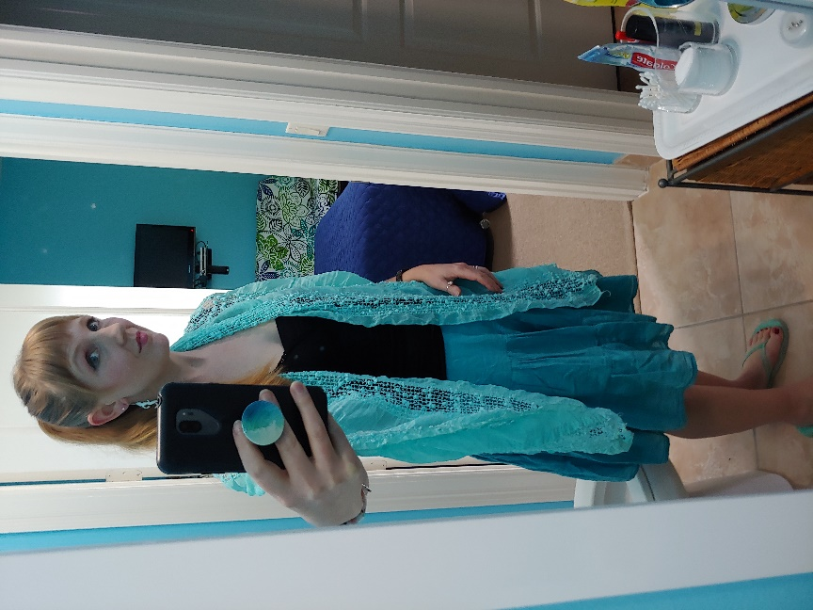
I could practically smell the money and wealth (and a serious amount of booze) coming off the people dancing in the IPC. I saw shoes that were worth more than a month of my pay, and immediately felt completely self-conscious about my flip-flops… So, I did what anyone in my position would do- went into the bathroom and gave myself a bit of a talk, then wandered outside and phoned a friend for moral support. I still didn’t see any horses, and if there was a dinner being served, it was not apparent, and my stomach was growling.

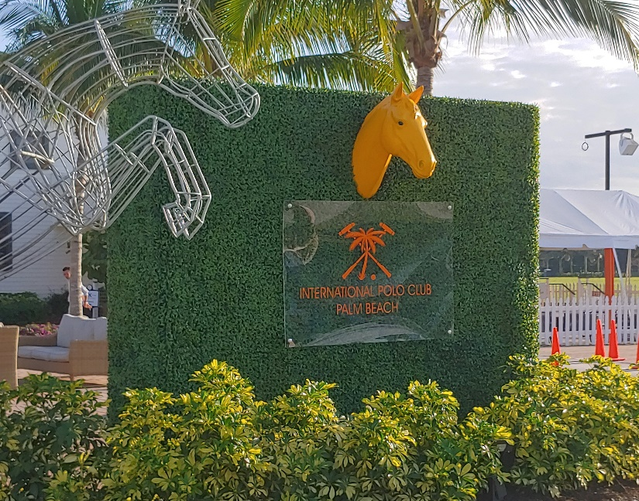
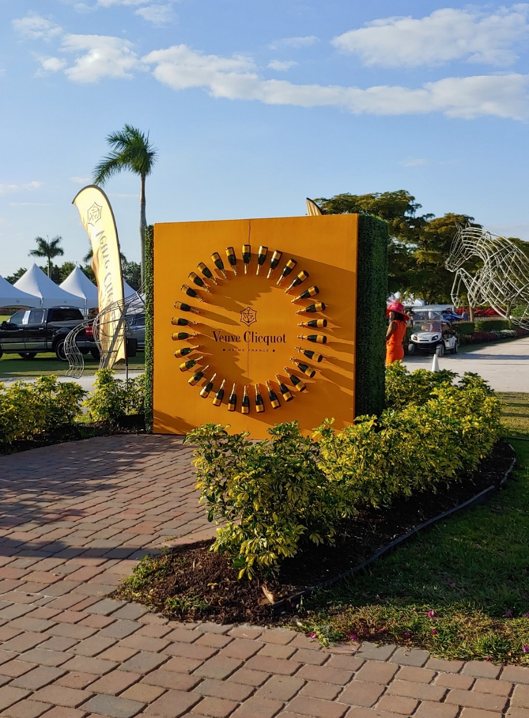
After getting off the phone with my awesome friend, I pulled on my big girl panties and went to ask someone. The woman I approached was very nice (and man, her shoes were gorgeous!), and she flagged down someone on a golf-cart to get me to the right spot.
After a two minute drive (the GPS was soooo close!), I arrived at where the actual Gladiator Polo match and dinner were happening. I walked in, and headed straight to the liquid courage dispensary to celebrate my arrival. I ordered a gin and tonic. It was served in a small plastic cup. Guess how much that cost? If you guessed $14, you win a gold star. $16 with a tip. So, it was a one drink kind of night for me.
After filling my plate with delicious food, I wandered around, trying to look like I belonged, and scoping the place for any other solo eaters. Finding one, I sidled up to the table and tried not to look too desperate. Luckily for me, the fellow took pity and asked if I wanted to sit down. We introduced ourselves, and another woman who knew him joined us. We chatted a bit, but the match had started, so most of my attention went to that. I had expressed to my table-mates that this was my first time seeing polo in real life, and they both said that I should really come to a full court game. Maybe next time…
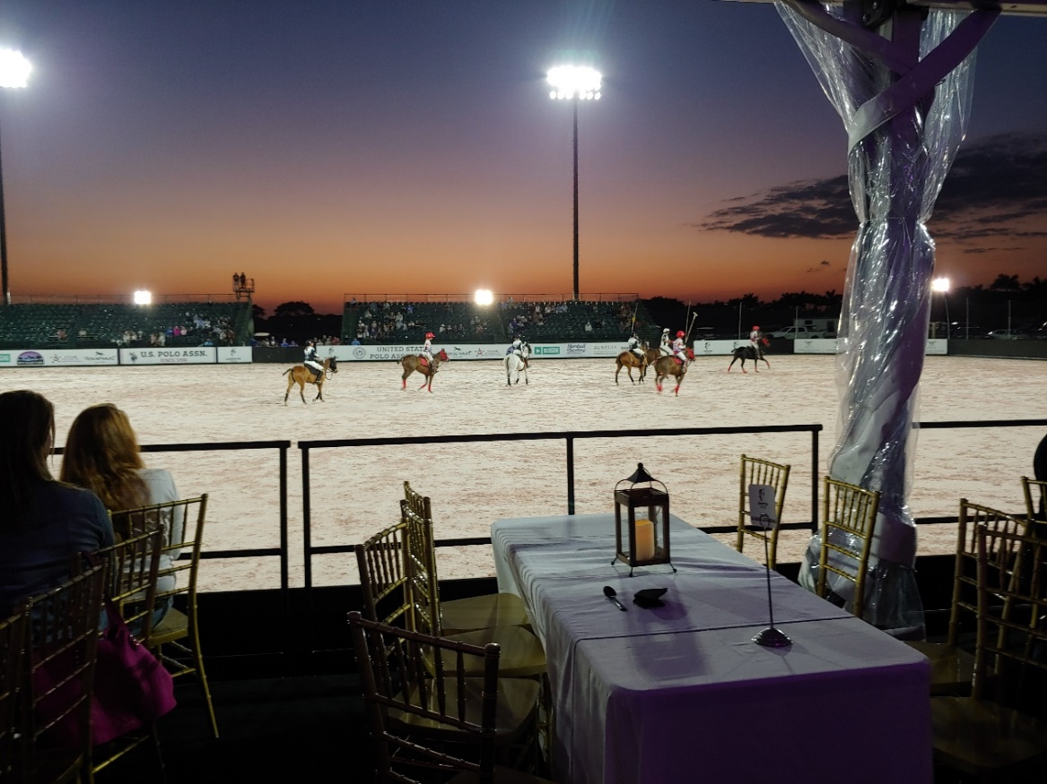
As it turns out, that fellow who had invited me to sit down is a pretty big deal in the polo world. His name is Jimmy Newman, and he is the Director of Polo Operations. I had no idea about that, but his friend (forgive me, I don’t remember her name) shared that fact after he had left the table, which made me sort of wonder if she was worried that the tart in Old Navy flips was angling for a sugar daddy. Funny stuff. Overall, the evening which had started with me feeling as though I was in way over my head, ended very nicely, and with a good story to tell.
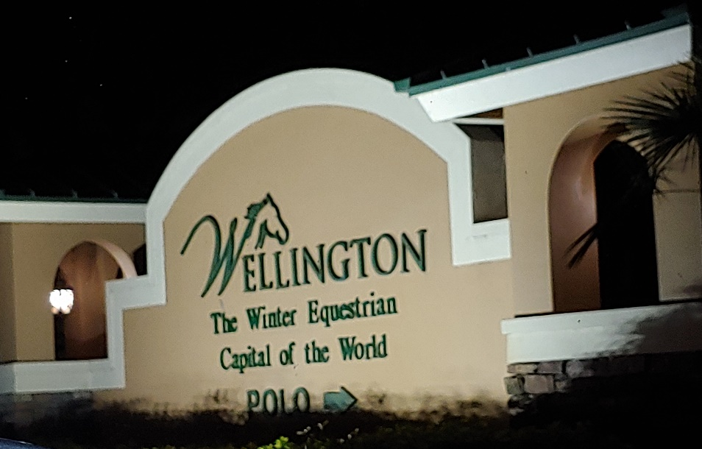

The next morning, I headed north to Gainesville, already dreaming of the next time I could make it to Wellington. With fancier shoes.

Ed Note: HUGE thanks to Michelle for sharing this fabulous story with us here! So much FUN!!!

Horse~Dog~Critter Sitting
Trish Chomyn experienced horse traininer and barn manager is returning to our area
***Experienced and Reliable***
stay-on-your-farm or drop-in (within reason)
Several years experience with senior dog rescue. Quality references and local referrals.
Contact 541-915-1064 or email delenn@nu-world.com

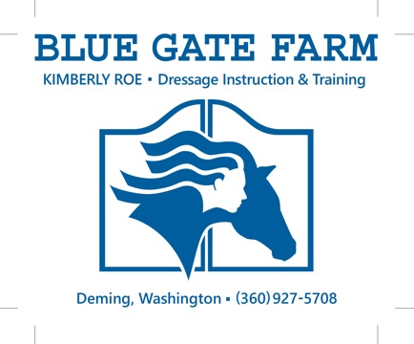
Member benefit – FREE business card advertisement. To be included here, send a pdf of your card or logo to the newsletter editor.

