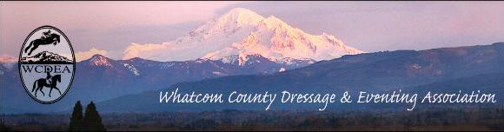
  - February 12, 2019

NEXT MEETING
CONTACTS

President:
Kate Simmons
andykatys@gmail.com

Vice President:
Robin Probst
rphrse@msn.com

Treasurer:
Carol Landt
landthuber@gmail.com

Secretary and
Website Coordinator:
Michelle Becker
goddessgirl19@hotmail.com

Newsletter Editor:
Deborah Cole
dchoneydofarm@gmail.com

Mass Email Distributor:
Linda Cain
cainshome4@gmail.com

Like us on FaceBook:
https://www.facebook.com/wcdea

Website Address:
wcdea.net

THURSDAY ~ February 21 6:30pm
In the side room of
Bob’s Burgers and Brew
Barkley Village
2955 Newmarket St

WCDEA Meeting Minutes January 17, 2019
Members attending #9
Meeting Called to order 6:30
Financial Statements: Peoples Bank –
Checking $ 1,777.06
Peoples savings:
Calendar $300.00
Leg Up Fund $487.24
Savings (regular) $3,629.20
Total Peoples savings (regular) $4,416.44
Total Checking/Savings $6,158.50

Old Business: Approval of minutes from November meeting. We do still need to get the financial info about the Karen Pavicic clinic.
Carol is organizing the treasury box (archiving older documents) and just making it to her liking.
Thank you to the previous board members- Kat, Garyn and Malinda, and a thank you to Michelle for continuing on.
New Business:
Intros to all in attendance.
Signing of the “legal” documents by all board members present. Once Carol has signed, we can send the document in to USDF.
By-Laws: spending limit, board had proposed $200, but members recalled that the previous year the limit had been raised to $500-this was voted on and approved.
On the topic of spending, Deb proposed that the board have the ability to send out an “emergency” newsletter, in the event that the board needs votes/member approval on spending immediately. (ed. note: This would suffice as notice to the membership per our by-laws regarding publication of the intent to vote at the next meeting)
Membership was discussed, along with the possibility of offering a “lifetime” membership. This will need further discussion.
Lynn Salas offered to look over the by-laws with Kate, to see if updates need to be made. (Some changes have happened, but aren’t reflected in the by-laws).
The Board mentioned that it will be purchasing the new dressage tests, and then getting copies made for the Show Box. Dawn mentioned that there is a YouTube channel that has the new tests being ridden, with a judge explaining the movements. Dawn finds it very useful. She’ll try to send a link to Deb Cole, so it can be added to the newsletter, and possibly the website. (ed. note: Each test has a separate video on YouTube. Search YouTube for CDS San Diego Test Symposium and you will get a slew of new dressage test viewing pleasure)
On to planning for the year!
The hope is to have quarterly/seasonal programs, along with a few shows/clinics. We will be looking to partner with other groups in the area putting on shows- try to split the cost of the venue, and share volunteers, along with get exposure to other equestrian activities.
Feb- More planning, and finalizing ideas
March-Short meeting with a program: Dr. DeJong from Kulshan vets to talk about bio-security, especially at shows. Deb Cole will talk with Kulshan. Probably meet at WECU again, it’s a good place for a talk.
April- Ride-A-Test/% show? Maybe morning RAT and afternoon %? On the 21st?? This could either happen at Patti Yust’s, or if we partner with someone like Kim Barber. It was mentioned that getting a Canadian L judge is cost effective. We’ve had Adrian Lucianna in the past, and she was a good judge/trainer for riders.
*This led to a brief discussion about if the club’s purpose was to make money or offer education opportunities. (Hopefully we can do both). Further discussion into marketing and attracting new members. All present agreed that marketing was worth spending some money on. The Board will need to come up with a percentage of the annual income that could go towards marketing. Kate will also be talking to a friend who makes banners, to see if a free/cheap banner can be made that we can have at tables when attending other shows/events or when hosting our own.
-Kate mentioned that Burkwood was having a show the weekend of 1/19, and if anyone wanted to go, they could bring membership forms. The WWU Equestrian Team will be having a show in February. We should try to have some representation at it Here’s a link: https://nwwafair.com/events/2019/wwu-equestrian-team-show
-Kim Roe will also be hosting a Working Equitation event on April 20th, so we’re trying to be mindful of that.
May- Regular meeting, talking about summer/fall events.
-Discussion about possibly trying to make something work with the Morgan Horse Show people, for a rated show in 2020… To be continued…
June- Schooling show, the first weekend of June. This will be a good opportunity to try to work with other groups. Parking would be limited at Broken Auger, so we’ll need to try to see if we can do something at either Creidmont, or Lynden, or???
July- Fun day! and CELEBRATE Lynn’s birthday!! A new idea- to rent a vehicle that will hold 10-15 people and to go on a cheese/wine/cake barn tour! This idea was met with enthusiasm by all!
August- Meeting/Program with the Whatcom Conservation District
September-Schooling Show the 21st or 22nd, at Broken Auger?
October- Meeting/Program? Intro to driving, or Working Equitation?
November- Elections
December- Holiday Party and Year End Awards
The WCDEA Year End Awards Program is needing more modification to make way for more inclusion of our members’ activity. Deb Cole would like to hear from Eventers, Drivers, Working Equitation, and Fox Hunting enthusiasts (Yes, our members DO all those things! Exciting, huh? Please contact her to discuss realistic goals/rewards for the WCDEA 2019 season.
Kate mentioned, briefly, the idea of a points system for various (volunteer) things, in order to get people more involved. This will be talked about further at the February meeting.
It was mentioned that the Treasurer is in charge of the Dressage Bucks. So, those putting on shows, or needing to give them to volunteers, should check in with the Treasurer.
Other Announcements:
New/returning member Trish Chomyn, is looking for a short term place to live in the area.
The next meeting will be February 21st, at either Bob’s or Mi Mexico.

These minutes will not be read at our next meeting. If there are any corrections, please email board members.

Meeting was adjourned at 8:01 pm.
Respectfully submitted,
Michelle Becker WCDEA Secretary

Life Hacks for Farm Life in frozen weather:
Crisco – for packing into horse hooves. Keeps the snowballs from forming/sticking (but you’ll want to groom in the stall to avoid staining concrete with grease)

Spray No-Stick, Cooking Spray, PAM – keeps your muck bucket dumping easier because it prevents muck from freezing/sticking inside. Also good to use on the tines of plastic muck forks.

Have a bucket that you need to keep frost free, but no electricity? Try the adhesive type of air activated foot warmers – or use vet wrap to secure the non adhesive type. Another trick is to use several medium sized river rocks which have been heated in an oven for an hour or more to 200. Make sure there is water in the bucket before you drop them in to avoid cracking cold plastic (or melting).

Keep your own hands extra insulated by doubling up your gloves – try wearing a pair of nitrile gloves inside your work or riding gloves for extra warmth.

MARKET PLACE – FREE ADVERTISEMENT OF GOODS FOR SALE – MEMBER BENEFIT
To be included here, please send your ad and photo(s) to the Newsletter Editor and be sure to update when the item is no longer available.

Horse~Dog~Critter Sitting
available beginning January 2019
Trish Chomyn experienced horse traininer and barn manager is returning to our area
***Experienced and Reliable***
stay-on-your-farm or drop-in (within reason)
Several years experience with senior dog rescue. Quality references and local referrals.
Contact 541-915-1064 or email delenn@nu-world.com

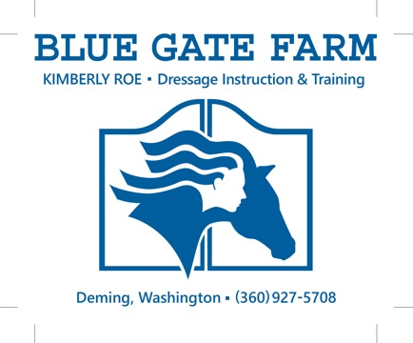
Member benefit – FREE business card advertisement. To be included here, send a pdf of your card or logo to the newsletter editor.

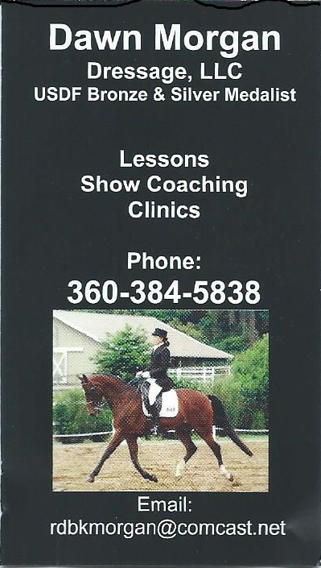

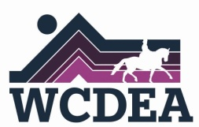
Whatcom County Dressage & Eventing
Association

Meeting Agenda
Date Feb 21, 2019
Time 6:30pm dinner, 7:00pm meeting start
Location Barkley Bob’s Burgers

1. Call to order 1 min

2. Welcome & Roll call 1 min

3. Approval of minutes from last meeting 5 min

a. Minutes are sent with the newsletter, please review prior to the meeting

4. Treasurer’s Report 5 min

5. Old Business 25 min a. Report of Karen Pavicic clinic
b. By Law review/updates c. Audit update
d. 2019 event dates - coordinators/leads needed

6. New business 20 min a. Marketing fund
b. **Send new business items prior to meeting**

7. Announcements 10 min

8. Next Meeting 5 min

a. Thurs, March 21 6:30pm - WECU Ferndale - Very brief meeting & program - Dr.

DeJong - Equine Bio Security: Common Sense Ways to Protect Your Horse and the Horse Community’s Health. Non-Members welcome, please invite others.
9. Adjournment

The Whatcom County Dressage and Eventing Association (WCDEA) is a not for profit organization founded in 1984 for the promotion and education of dressage and eventing for enthusiasts in Whatcom County and surrounding areas.

