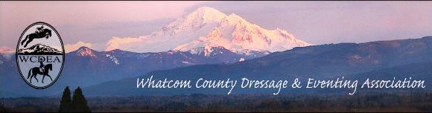
  - JuLY 16, 2019

NEXT GATHERING
CONTACTS

President:
Kate Simmons
andykatys@gmail.com

Vice President:
Robin Probst
rphrse@msn.com

Treasurer:
Carol Landt
landthuber@gmail.com

Secretary and
Website Coordinator:
Michelle Becker
mbecker704@gmail.com

Newsletter Editor:
Deborah Cole
dchoneydofarm@gmail.com

Mass Email Distributor:
Linda Cain
cainshome4@gmail.com

Like us on FaceBook:
https://www.facebook.com/wcdea

Website Address:
wcdea.org

FUN DAY AT SUNSET FARM EQUESTRIAN PARK
Instructional Open House, Dressage Demonstrations
and LUNCH Pot Luck
Saturday, July 27th
The fun starts at 9am and goes all day

June 20, 2019 WCDEA Meeting Minutes
Location Baker Creek Grill @ Bellingham Golf & Country Club
Members attending # 8
Meeting Called to order 7:02
Financial Statements: Peoples Bank –
Checking $ $1603.87
Peoples savings:
Calendar $300.00
Leg Up Fund $487.24
Savings (regular) $2633.45
Total Peoples savings (regular) $3420.69
Total Checking/Savings $4024.56
Old Business
- Storage of Club belongings
We discussed the storage of Club ‘stuff’…Decided that an inventory should be done, and Lynn Salas graciously offered her barn as an area to store things. Her location is fairly central and at this point she will not charge the club.
Michelle currently has a good portion of “the stuff” so she’ll talk with Lynn about finding a time to move it into her barn in the next month or two.
- August Working Equitation (WE) show - progress/update
The entry form is live on the WCDEA.org website, and on FaceBook. Volunteers are needed to help set-up on Saturday, and Sunday. It was also noted that Cindy Lucas has a bull…
c. Program Recap - Working Equitation with Kim Roe
Discussion about how fun this event was, and that we had some new faces from Misty River; and importantly, that WE is definitely something that is gaining in popularity. Discussion about how to incorporate more WE events into the Club’s doings, while still staying true to the mission…. More discussion will need to happen.
New business
- July Fun Day:
(which we also use as a way to celebrate Lynn’s birthday). Decided that we would combine the Fun Day with the Instructional Open House at Sunset. Everyone bring a potluck item, including beverages and either ride, or watch others ride and enjoy each other’s company in the beauty of the park.
- July Instructional Open House @ Sunset Park - co-hosted with Friends of Sunset Farm (FOSF)-
This is happening on July 27th. This should be a fun and educational event, where there will be demo dressage riders from Dawn’s barn in the morning, and Cross Country schooling with a free Event Derby lecture and a mock Event Derby course walk! More information is on the Friends of Sunset Farm page.
Next Meeting: No business meeting in July
August 15, 2019 - Monthly Meeting & Program - location TBA (Now slated for WECU Ferndale)
Meeting Adjourned at 7:52
Respectfully Submitted by WCDEA Secretary, Michelle Becker

WCDEA President, Kate Simmons sez:
Helloooo Members and happy July!!

The middle of the year is here and suddenly there's everything on the calendar!

I'm sure many of you are in the midst of show season - feel free to send in reports of how you and/or your barn team are doing! We're a community and it's always fun to hear what our community members have been up to - it's a great chance for our member-trainers to share their team successes as well. If you don't show, maybe you've been to a great clinic, or gone and done something different, or had a miraculous break through with your half-halts! Whatever your success or fun thing, share it! The newsletter (send stuff to Deb Cole) and the FaceBook page are great avenues for sharing.

July brings no meeting, but an alternative fun-day instead. We're teaming up with the Friends of Sunset Farm to host an instructional open house at Sunset Farm Equestrian Park on Saturday, 27 July!! Our mission is education about our sport and this is a great opportunity to share and answer questions. There will be a cross country schooling day (you can find the entry via Friends of Sunset Farm) and a mock course walk along with valuable information for those new to the sport about the starting box and other things that maybe some of us take for granted and others are too shy to ask. If you've wanted to dip your toe into eventing, or know someone else who does, be sure to share this event! Our thanks to Viki Schimke for being our Eventing coach for the day. In addition to the eventing, we'll have the dressage arena set up with narrated demo rides planned for the morning and open arena in the afternoon. Our thanks to Dawn Morgan and her riders for volunteering to show our guests that dressage is for all and any level is achievable!! Again, if you know someone that is interested in dressage, please send them out for this event. All riders and enthusiasts of all disciplines are welcome to come - Sunset Farm is a wonderful asset in our community, and this will be a great way to show it off.

Most importantly, I'm going to ask all of you to carve some time out of your day to attend and support this event. Whatever level you ride at, train at, aspire to... whether you're a dressage enthusiast and spectator only or training 6 days a week... this event is our chance as an organization to really fulfill our mission. Come out, enjoy the day, invite your friends, chat about dressage and eventing, answer questions, encourage new people to learn more about the sports that we love. And besides, we're going to do our July potluck on the same day, so pull together your favorite dish and join us! Details will be on the FB event and on the club calendar.

August kicks off with the FOSF derby on the 3rd- a great chance to get in a dressage test and/or do some cross country and jumping. This lo-key event is perfect for newbies, young horses, and those who want to get out in a low pressure situation. Again, tell your horsey friends and encourage new people to give it a try!

August 18th is super exciting because it's our very first Working Equitation competition!! This rapidly growing sport has dressage at its core with obstacles to make it fun and definitely entertaining! There are very few schooling show opportunities on the north end, so we anticipate a good response and encourage everyone to come check it out. Volunteers will be needed, so please contact Carol or Lynn and keep your eyes peeled for details. Entries are available on our FB event and on our website. Our thanks to Kim Roe, Carol Landt and Lynn Salas for making this exciting schooling show happen!

We also resume our monthly meeting in August. We'll be meeting at the WECU in Ferndale on the 15th and are pleased to have the Whatcom Conservation District coming to share some of the great programs and grants they have available, and to give you some great ideas for prepping your horse property for winter. All are welcome to attend.

Lastly, November will be here before you know it! That means BOD elections and probably some more frank discussions about the direction of the organization. Our mission is the promotion and education of dressage and eventing for enthusiasts in Whatcom County and surrounding areas....what does that look like as we move forward into the years ahead?

See you all in July, and happy riding!!

BIG NEWS…No
HUGE…
SUPER IMPORTANT…PLEASE NOTE
The WCDEA website domain has changed to “.org”
So, the new, slightly changed address is now
www.wcdea.org

Horse ~ Dog ~ Critter Sitting
Trish Chomyn experienced horse traininer and barn manager is returning to our area
***Experienced and Reliable***
stay-on-your-farm or drop-in (within reason)
Several years experience with senior dog rescue. Quality references and local referrals.
Contact 541-915-1064 or email delenn@nu-world.com

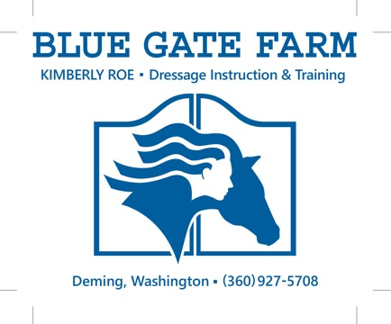
Member benefit – FREE business card advertisement. To be included here, send a pdf of your card or logo to the newsletter editor.

