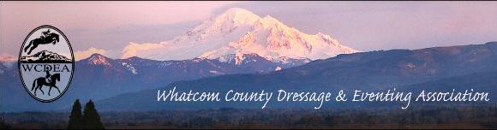
  - NOVEMBER 28, 2016

CONTACTS

President:
Emily Dieleman
emilyjdieleman@gmail.com

Vice President:
Kat Southam-Fay
katsoutham@gmail.com

Treasurer:
Holly Nachbar
hnachbar@comcast.net

Secretary:
Kelly Dress
kjdress@gmail.com

Newsletter:
Deborah Cole
dchoneydofarm@gmail.com

Website Coordinator:
Michelle Becker
goddessgirl19@hotmail.com

Email Distributor:
Linda Cain
cainshome4@gmail.com

Like us on FaceBook:
https://www.facebook.com/wcdea

Website Address:
wcdea.net

NEXT GATHERING ~
HOLIDAY PARTY
12~3pm DECEMBER 10th
510 N. State St., Bellingham
.
WCDEA 11.17.16 Meeting Minutes
There were 21 in attendance at the meeting held at El Gitano in Bellingham. President Emily Dieleman called the meeting to order at 7:08 pm.

OLD BUSINESS:
- End of year re-cap. (attached) Emily presented the discussion highlighting our 2016 club activities. We had a busy year with great participation from our members! Thank you to everyone who helped make it a great year!
- Holly Nachbar provided a financial report. After paying expenses, we have made $180.
- We are planning an advanced horse first aid course with Dr. Zaccardi. The date has not been set, but we are looking at early 2017.
- First aid for equestrians, presented by Ann Curtis, is still being planned. Both equine and equestrian classes will be held in early 2017, and will be on alternate weekends. Emily will provided updates with dates/times.
NEW BUSINESS:
- Deb Cole requested content from the members to publish in the newsletter. Members who have participated in events in and outside of WCDEA are encouraged to share their experiences with the club. Send those materials to Deb by the 7th of each month via email: dchoneydofarm@gmail.com
- Mechelle Sieg requested that year end re-caps should be compiled and stored with club documents. This will enable us to keep track of activities and see trends.
- Logo. Emily will work on our existing logo to simplify for a better embroidery pattern. Options will be put out for an email vote in our December newsletter. Once a logo is approved, we will obtain quotes for embroidery on pads, shirts, etc.
- Sara Singleton made a motion to hold business meetings at El Gitano going forward. All approved.
- Request for help on club web-site! Anyone with experience would be greatly appreciated to maintain our site.
- Christmas party! Our annual party will be held on December 10 at the home of Erin Recke and Shanna Leeland. 12 to 3 pm. 510 N. State St., Bellingham.
- Board vote. Nicol Hinde made motion to retain all current board members. Mechelle Sieg seconded. Holly Nachbar accepted the nomination of Treasurer. Kelly Dress accepted the nomination of Secretary. Kat Southham-Fay accepted the nomination of Vice-President. Emily Dieleman accepted the nomination of President. Michelle Becker made motion to accept board members for 2017. Mechelle Sieg seconded. All approved.
Please remember our January 19th meeting will be held at El Gitano. Come to eat at 6:30, and join the meeting at 7:00. This will be our 2017 planning meeting. Bring your ideas!
These minutes will not be read at our next upcoming meeting. If there are any corrections, please email board members.
Emily Dieleman: emilyjdieleman@gmail.com
Kat Southam-Fay: katsoutham@gmail.com
Holly Nachbar: hnachbar@comcast.net
Kelly Dress: kjdress@gmail.com
Meeting adjourned at 8:01 pm
Respectfully submitted,
Kelly Dress, Secretary

TIME TO RENEW YOUR MEMBERSHIP
IF YOU HAVEN’T ALREADY,
PLEASE PRINT ATTACHED MEMBERSHIP APPLICATION AND
SEND TO HOLLY ASAP

WHATCOM COUNTY DRESSAGE & EVENTING ASSOCIATION
2017 MEMBERSHIP APPLICATION

Name: (First)_____________________(Last)____________________(Middle Initial)_____

Date of Birth:____/_____/______

Address: _____________________________________City_______________________ Zip__________

Phone (_____)_________________E-Mail Address: ________________________

Emergency Contact Name (and relationship) __________________________________

Emergency Contact Phone Number____________________________

Membership:(please check one) New________ Renew________ USDF #______________________

May we list you as a member on our website? circle one YES NO (We list name and county of residence only on the website) Once or twice a year we publish a list of members that is included in a newsletter; may we include your name and contact information for members only? YES NO (it’s never shared outside our club): ___ Regular Membership: 35.00 if paid by November 14th, 2016 and for students with a valid ID all year. 50.00 if paid after November 14th (except for students). This includes full membership in the WCDEA and a group membership in USDF. This will include voting rights in WCDEA affairs (for members 18 years of age and older), reduced rates for WCDEA sponsored activities, and email delivery of the monthly newsletter.

Family members residing at the same address may be added for $10 each and snail mail delivery of the newsletter may be had by adding $5 to the first membership. Please list additional family members to be added to your membership below: ____________________________________ ____________________________________

Newsletter Subscription Only: Keep in touch with what is going on in the local dressage and eventing scene (no membership benefits). Fee is $10 per year for email delivery and $15 per year for snail mail delivery.

Make checks payable to WCDEA and mail to: Holly Nachbar, 3364 Opal Terrace, Bellingham WA 98226

We are always in need of volunteers! No experience is necessary, just your enthusiasm and willingness to help. Please mark the area(s) that interest you most:
___Shows ___Clinics and Education ___Calendar ___Outreach ____Advertising ___Wherever needed!

Member advertising is free for business cards. Please email (dchoneydofarm@gmail.com) an attachment of your scanned version (jpg or pdf) to be included.
2016 YEAR END RE-CAP
Meeting Attendance:
January 21, 2016 - 17
April 21, 2016 – 8
July 16, 2016 – 10
October 27, 2016 – 8
Education/Event Participation:
2/12/2016Emily Dieleman
Artist/Teacher
Participants - 13 members/12 non-members (21%)
3/25 – 3/26/2016Working Equitation Clinic
Instructor
Participants – 14 riders/several auditors (23%)
4/17/2016Ride-A-Test
Judge: Kim Roe
Participants – 14 (23%)
5/14 – 5/15/2016Jessica Wisdom Clinic
Trainer/Instructor/Coach/Superhero
Participants – 11 riders/several auditors
7/16/2016Sunset Park Fun Day
Participants – 10 (5%)
9/10/2016Fall Schooling Show
Judge: Kimmy Weise
Participants – 22 (36%)
9/22/2016Equine Structural Integration
Monica Urchurtu
Participants – 16 (25%)
Membership:
2015 – 51
2016 – 62 (increase 20%)
Financial:
2015Checking $695.70
Savings $6,150.75
Leg-Up $657.75
Calendar $300.72
Total Assets $7,804.92
2016Checking $1,601.53
Savings $5,747.42
Leg-Up $472.24
Calendar $300.00
Total Assets$8,121.19 (4% increase)

MARK YOUR CALENDARS NOW FOR THE JANUARY 19th PLANNING MEETING SO THAT WE CAN CONTINUE THIS GREAT TRADITION OF OFFERING FANTASTIC EXPERIENCES TO OUR MEMBERSHIP AND THE HORSE COMMUNTIY IN GENERAL

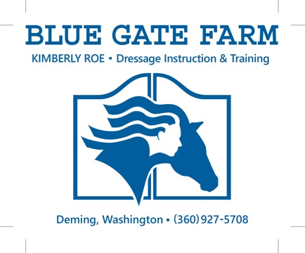

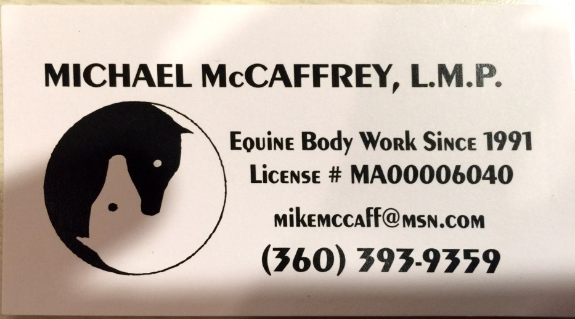

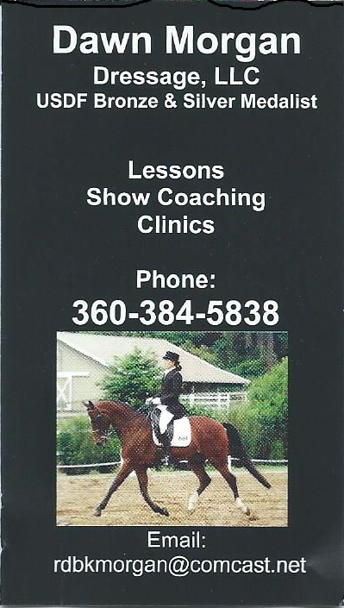

FOR SALE:

** Parma ARENA Groomer in good condition - 3 point hitch type for $1,000

(half price of new one). Contact Barbara Daugert at bdaugert@gmail.com or phone 360-483-8031.

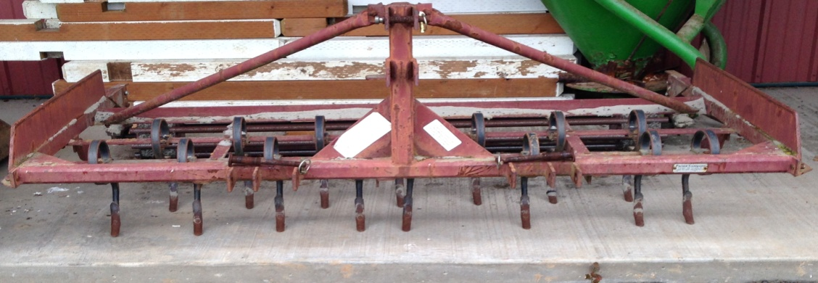

WCDEA News is published and distributed to the WCDEA membership. We value your ideas and opinions – PLEASE let the editor know of any items that could be included as news for future publications. (please know that stories will be checked out for accuracy prior to print to the best of the Editor’s ability) Send your News Submissions to: Deborah Cole via email: dchoneydofarm@gmail.com. WCDEA members meet monthly (typically) at various locations announced in the newsletter and website at http://wcdea.net

